A Project Report
on
Impact of Global Warming on Energy Demand

Submitted to:
Syracuse university

Instructor:
- Prof. Christopher Dunham
- Prof. Erik Anderson

Course name: Introduction to Data Science (IST-687)

Group Name: Group 5

Members:
- Malhar Mahajan
- Ethan Radecki
- Jaswanth Srinivas Chandu Meesala
- Shuai Liu

Content
Sr. No. | Title | Page No.
1 | Problem Statement | 3
1.1 | Motivation | 3
1.2 | Goal | 3
2 | Data and Resources | 4
3 | Approach and Methodology | 5
4 | Methodology | 6
4.1 | Data Loading | 6
4.2 | Data Merging | 7
4.3 | Data Validation | 8
4.4 | Data Understanding | 8
4.5 | Data Cleaning | 8
4.6 | Variable Analysis and Data Segmentation | 8
4.7 | Data Modelling | 8
4.8 | Regression Analysis Report | 10
4.9 | Accuracy Testing | 13
5 | Evaluating Peak Future Demand | 15
6 | Recommendations for Energy Efficiency | 19
7 | Shiny Application | 21
8 | Challenges | 22
9 | Project Timeline | 23
10 | Team Contributions | 24

1. Problem Statement
The Energy company (eCS) anticipates a significant increase in energy demand next summer due to the impact of global warming, which is expected to cause exceptionally hot weather. This surge in demand, particularly in July—historically the peak month for energy usage—raises concerns about the company’s ability to supply sufficient electricity. Without proactive measures, this heightened demand could lead to blackouts

1.2 Motivation
The primary objective of this project is to ensure that eSC can meet the projected energy demands during the upcoming summer without the need to invest in building additional energy production facilities. To achieve this, the company aims to:
- Identify the key drivers contributing to peak energy consumption.
- Develop strategies to encourage customers to adopt energy-saving behaviours.

In addition to addressing supply challenges, this initiative aligns with eSC’s commitment to environmental sustainability by:
- Minimizing its carbon footprints
- Reducing greenhouse gas emissions
- Avoiding the environmental impact associated with constructing new power facilities.

1.3 Goal
The goal of this project is to:
- Analyse and pinpoint the primary factors driving high energy usage.
- Based on the analysis, developing strategies to encourage customers to conserve energy.

This dual approach will help the company balance grid load, prevent blackouts, and significantly reduce its environmental impact, supporting broader sustainability objectives.

2. Data and Resources
The following datasets have been provided by the company to analyse energy usage and trends, aiming to identify the major contributors to energy consumption:
- Static House Data:

- File URL: https://intro-datascience.s3.us-east-2.amazonaws.com/SC-data/static_house_info.parquet
- This dataset contains information for a list of houses, including attributes such as house size, building ID, number of bedrooms, and other details that describe each property.
- Primary Key: bldg_id (Building ID)

- Energy Usage Data:

- File URL: https://intro-datascience.s3.us-east-2.amazonaws.com/SC-data/2023-houseData/102063.parquet
- This dataset contains energy usage data recorded hour-by-hour for building number “102063”. It includes energy consumption details for various appliances, such as ceiling fans, dryers, washers, and more.
- To access energy usage data for other houses, you can modify the ‘buildingid’ (i.e. 102063) in the URL to reference other buildings from the static house data.

- Weather Data:

- File URL: https://intro-datascience.s3.us-east-2.amazonaws.com/SC-data/weather/2023-weather-data/G4500010.csv
- This dataset provides hourly weather data for county ‘G4500010’.
- To extract weather data for other counties, replace the county ID in the URL with the relevant county ID from the static house data.

- Meta Data:

- File URL: https://intro-datascience.s3.us-east-2.amazonaws.com/SC-data/data_dictionary.csv
- This file contains descriptions for the attributes used in the static house data, energy usage data, and weather data, providing a detailed explanation of each field.

3. Approach and Methodology
The following plan outlines the steps to achieve the project goal of understanding energy usage patterns and identifying key factors contributing to energy consumption:
- Data Loading:
- Loading Data into R:
Use appropriate R functions to load data from CSV and Parquet file formats into RStudio.

- Energy Usage Data Extraction:
Extract energy usage data for all individual houses using the bldg_id (building ID) and store it in a new data frame for analysis.

- Weather Data Extraction:
Extract weather data for each county based on the county_id from the static house data.

- Filtering Data for July:
Focus the analysis on July, as it is predicted to be the peak month for energy consumption. This also enhances the performance of the code by reducing unnecessary data.
2. Data Understanding
- Exploring Data:
Use R functions such as str() and summary() to examine the structure and summary statistics of the data frames. This step helps in understanding the variables and their distributions.

3. Selecting Data Selection and Merging:
- Variable Selection:
After reviewing the data, select the relevant variables for analysis that contribute to energy usage patterns.
- Merging Data:
Merge the energy usage data, weather data, and static house data into a single data frame, ensuring that the data is aligned by house and county IDs.

4. Model Building:
- Developing predictive Models:
Build multiple models to predict hourly energy usage in the month of July with different algorithms and identify the most suitable model for accurate predictions.

- Model Evaluation:
- Assessing Model Accuracy:
Evaluate the performance of the model by comparing predicted energy usage values with actual values based on training dataset.
- Further using the model to test it on testing data set to ensure accuracy and avoid overfitting.

- Evaluating Energy Demands for July with a 5-Degree Temperature Increase
- Created a new dataset by increasing the dry bulb temperature by 5 degrees to simulate the effect on energy demand.
- Applied the developed model to predict the peak energy demand for the month of July under the new temperature conditions.

4. Methodology
4.1 Data Loading:
The following steps have been successfully completed for loading and preparing the data:
- Static House data:

- File Type: Parquet
- Library Used: Arrow
- Function: read_parquet()
- Description: Loaded the static house data from the Parquet file into a data frame using the read_parquet() function from the Arrow library. This allows for efficient data handling and manipulation.
- Code:
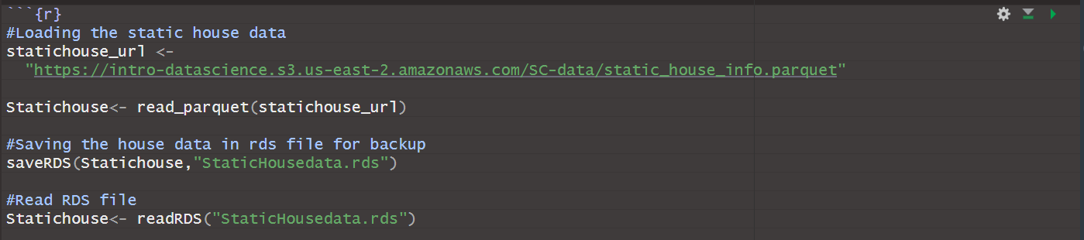
- Weather data:

- File Type: CSV
- Library Used: Tidyverse
- Function: read_csv()
- Description: The read_csv() function from the Tidyverse library was utilized to import weather data from a CSV file. A for loop was subsequently employed to iterate through all counties, extracting relevant data and storing it in a consolidated data frame named all_weather_data.
- Code:

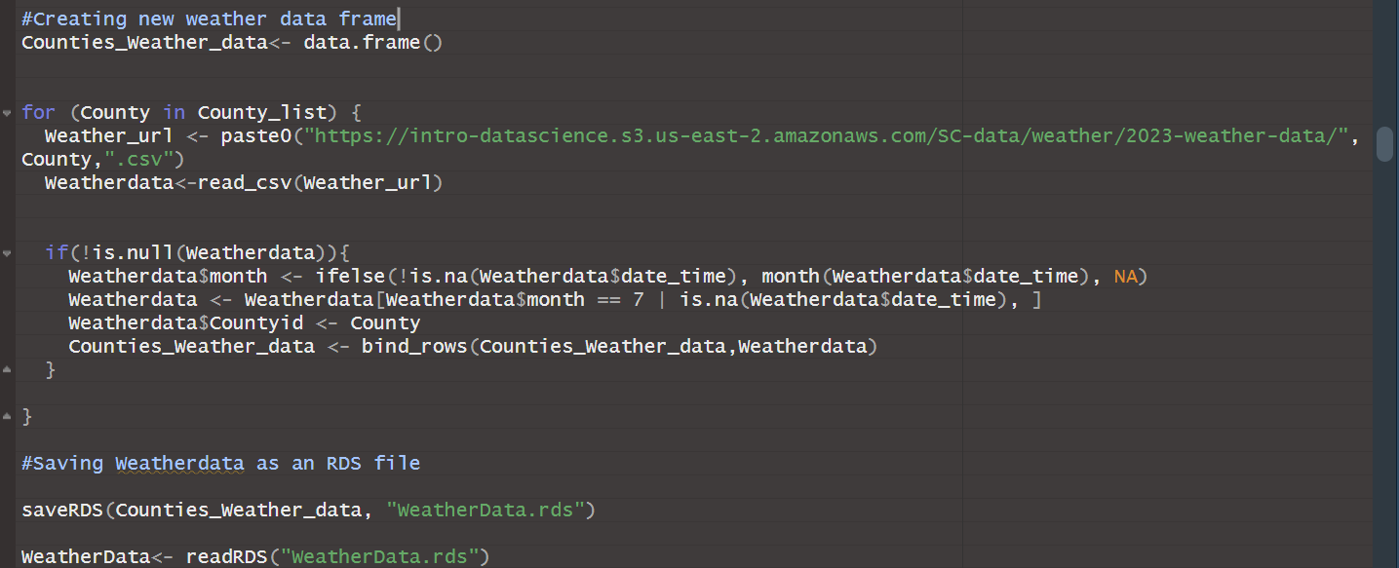

- Energy Usage Data:

- File Type: Parquet
- Library Used: Arrow
- Function: read_parquet()
- Description: The read_parquet() function was used to read the data from the parquet file. A for loop was subsequently employed to iterate through all building ID, extracting relevant data and storing it in a consolidated data frame named all_buildings_energy_usg.
- Code:

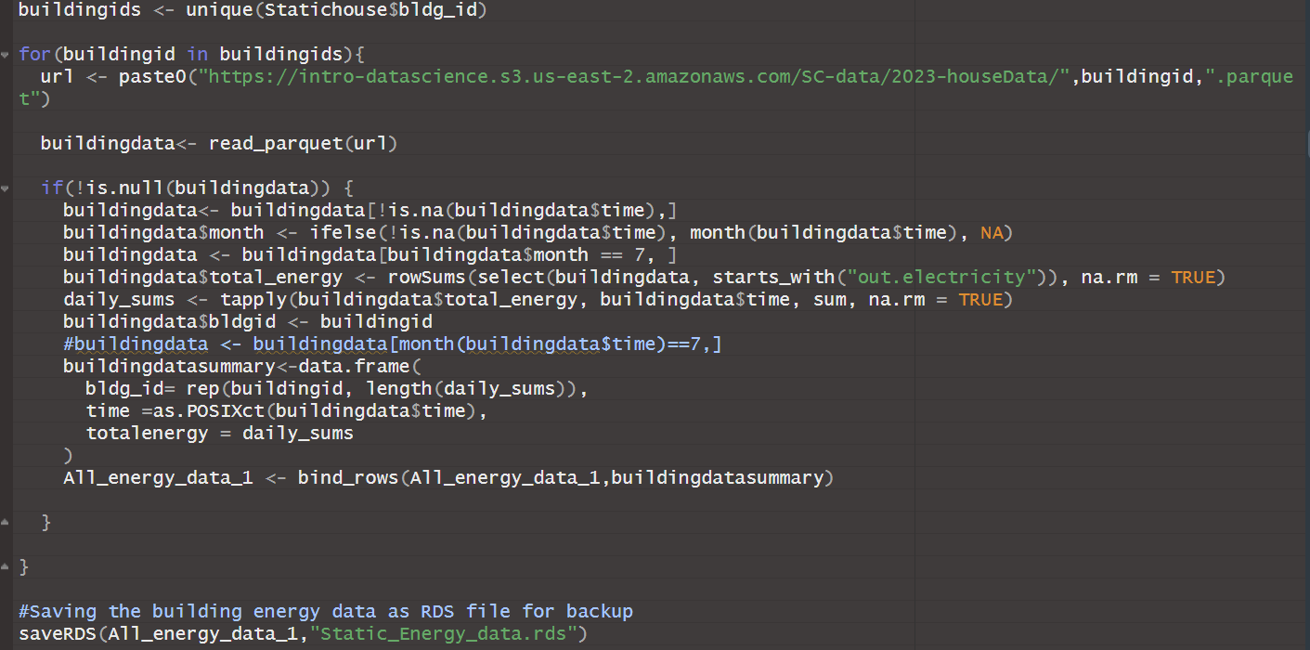

- Meta Data:

- File Type: CSV
- Library Used: Tidyverse
- Function: read_csv()
- Description: Loaded meta data from the provided CSV file, which contains descriptions for the attributes used in the static house, weather, and energy usage data files.

  - Data Merging:

- Initially, the static house and energy data frames were merged based on the building id column.
- Subsequently, the merged data frame was further combined with the weather data, using county and time as the key variables.
- It is crucial to ensure that the time variables in both data frames are in the same time zone to maintain data consistency and accuracy.
- Code:
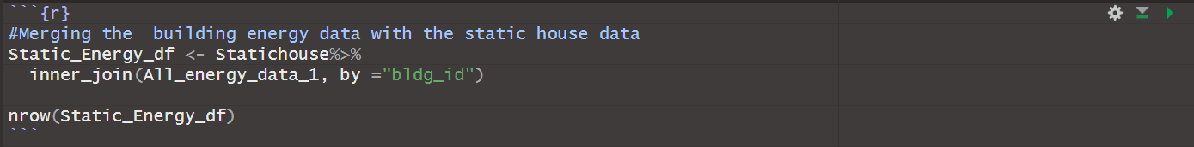

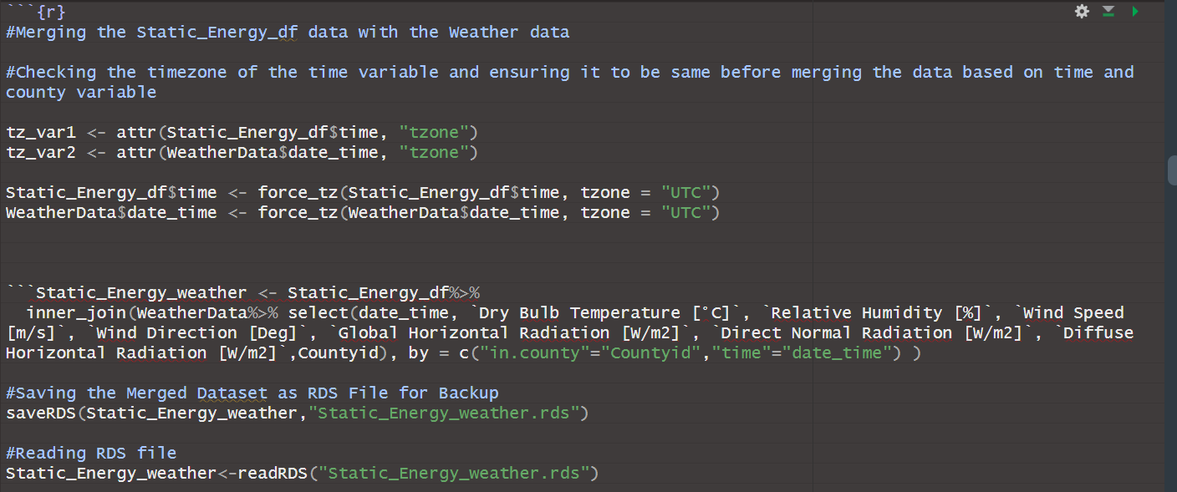

  - Data Validation:
- Conducted data validation to ensure data consistency and accuracy.
- Also, the missing values from each of the energy data for each building were removed to avoid errors in calculations.
- The dataset focuses on the month of July, a period when the company expected peak energy demand. Given that there are 5,710 buildings in the dataset, and observations of electrical appliance usage are recorded on an hourly basis, the total number of observations per building would be 5710 * 31 = 137,040 (for 31 days of July). Therefore, the overall dataset should consist of 137,040 * 31 = 4,248,240 total observations for the entire month.
- Code:
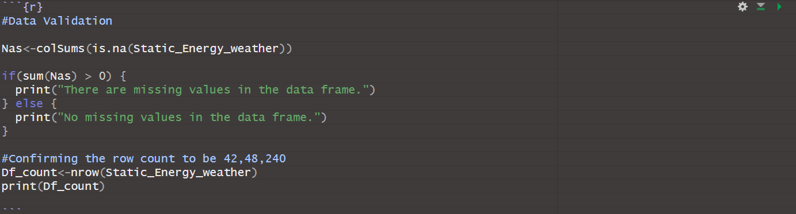

  - Data understanding
- Conducted a thorough analysis of the variables in the merged dataframe using functions such as str() and summary() to gain a comprehensive understanding of the dataset's structure and key characteristics.

  - Data Cleaning

- Cleaned the merged dataset to ensure it is ready for analysis.
- Removed irrelevant variables that had only one unique value or contained null values, ensuring that only meaningful variables were retained for energy trend analysis.
- Recoded categorical and numerical variables to standardize the dataset, which helped improve consistency and model performance.

  - Variable Analysis and Data Segmentation:
- Explored different methods to analyse variables.
- Divided the dataset into categories based on factors such as latitude, longitude, number of bedrooms, and time zones.
- Segmented the dataset into six distinct time zones: early morning, morning, afternoon, evening, night, and midnight.
- Performed stratified sampling within each time zone to capture energy trends at different times of day.
- Finally decided to create regression model on entire dataset in order to ensure accuracy in the conclusion and not have biased results.

  - Data Modelling:
- Developed a linear regression model to predict total hourly energy consumption.
- Divided the dataset into training and testing subsets to ensure robust model validation and generalization.
- Selected independent variables such as lighting type, cooling type, dry bulb temperature, humidity, number of occupants, square footage, time zone, and windspeed to capture the primary factors influencing energy consumption trends.
Below are the variables selected and the rationale for their inclusion:
- Lighting Type (in.lighting):
  - A categorical variable.
  - This variable plays a significant role in energy consumption trends. By analysing its effect, users can be encouraged to adopt lighting options with lower energy consumption to promote energy conservation.
- Cooling Type (in.hvac_cooling_type):
  - A categorical variable representing different cooling system types.
  - Cooling systems are a major factor in residential energy consumption. Identifying the most efficient cooling type can help promote its adoption, contributing to energy-saving initiatives.
- Dry Bulb Temperature:
  - A continuous variable.
  - Energy consumption for electrical appliances often depends on outdoor temperatures, making this a critical factor in the model.
- Dry Bulb Temperature × Cooling Type (Interaction Variable):
  - Captures the combined effect of temperature and cooling type on energy consumption. This interaction reflects how the efficiency of cooling systems varies with temperature changes.
- Humidity:
  - A continuous variable.
  - Humidity influences perceived temperature and affects the energy required for cooling and heating, making it an essential factor.
- Dry Bulb Temperature × Humidity (Interaction Variable):
  - Includes the interaction between temperature and humidity to better capture their combined impact on energy consumption.
- Wall Type:
  - A categorical variable.
  - Wall type influences the ability of a house to maintain its internal temperature, affecting insulation needs and energy usage. Insights from this variable can inform recommendations on efficient wall designs to reduce energy consumption specific the South and North Carolina region.
- Square Footage:
  - A continuous variable.
  - Larger homes consume more energy, making square footage a key determinant in energy usage trends.
- Number of Occupants:
  - A continuous variable.
  - Energy consumption patterns are influenced by household size. Larger households often require more energy for lighting, appliances, and HVAC systems.
By including these variables, the model effectively captures a wide range of factors affecting energy consumption, enabling actionable insights to drive energy conservation efforts.
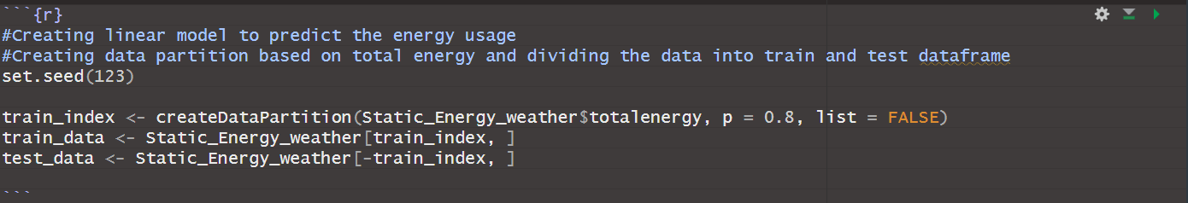
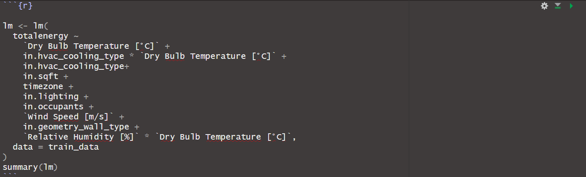

  - Regression Analysis Report:

- Adjusted R-Squared
The adjusted R2R^2R2 value of 0.3655 indicates that the model explains 36.55% of the variability in energy consumption. While this shows room for improvement, it suggests that the chosen variables provide meaningful insights into energy consumption.

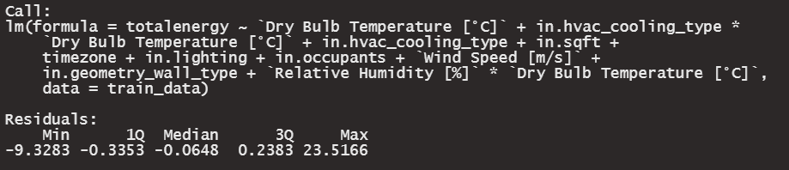
- Significance of Variables
All variables in the model are statistically significant (p<0.001p < 0.001p<0.001), confirming their strong association with energy consumption.

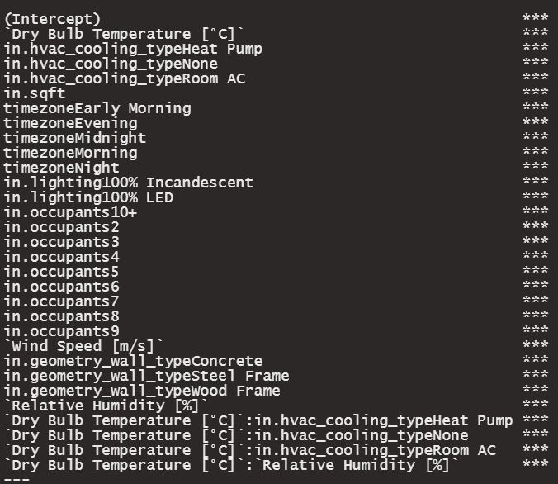

Variable Interpretation and Energy Consumption:
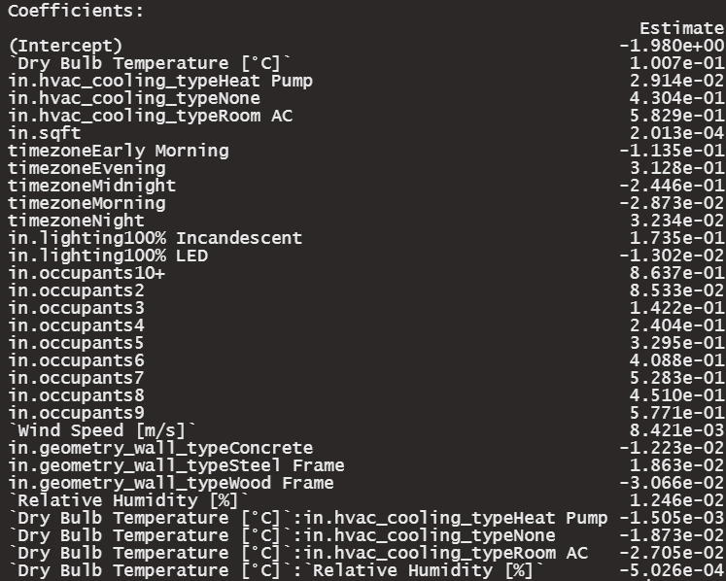
- Dry Bulb Temperature [°C] (+0.1007):
Energy consumption increases by 0.1007 units for every 1°C rise in temperature. This reflects greater HVAC usage during higher temperatures, increasing energy demand.
- HVAC Cooling Type: As the reference category, Central AC serves as the baseline for energy consumption. Other HVAC types are compared to this value, meaning that Central AC is the most energy-efficient in this analysis.
  - Heat Pump (+0.0291): The coefficient indicates that Heat Pumps slightly increase energy consumption compared to Central AC. While this represents a minor increase in energy use, Heat Pumps are generally considered efficient for moderate climates, providing both cooling and heating capabilities. However, in this analysis, they are marginally less efficient than Central AC.
  - None (+0.4304): This coefficient suggests a significant increase in energy consumption compared to Central AC. This could be due to reliance on less efficient cooling methods, or no cooling system at all, leading to higher overall energy use. This highlights the inefficiency of "None" as a cooling option.
  - Room AC (+0.5829): Room AC shows the largest increase in energy consumption compared to Centr

  - al AC. This indicates that Room AC is the least energy-efficient option, especially when considering larger spaces or higher cooling demands. Room AC units often have lower SEER (Seasonal Energy Efficiency Ratio) ratings, contributing to their higher energy consumption.

Conclusion:
Based on the regression analysis, the energy consumption increases for all HVAC types compared to Central AC, making it the most efficient option for cooling.
- in.sqft (+0.0002013):
Energy consumption increases minimally with square footage, as larger areas require more energy for heating, cooling, and lighting.
- Time Zone:
- Early Morning (-0.1135): Reduction in energy use, possibly due to reduced HVAC or lighting demand.
- Evening (+0.3128): Significant increase, likely due to peak lighting and HVAC usage.
- Midnight (-0.2446): Energy-saving period with reduced occupancy.
- Morning (-0.0287) & Night (+0.0323): Minor changes.
Recommendation: Focus energy-saving campaigns on evening peak hours.
- Lighting Type:
- 100% Incandescent (+0.1735): Increases energy significantly.
- 100% LED (-0.0130): Decreases energy use.
Recommendation: Transition to LED lighting to save energy.
- Number of Occupants:
Energy consumption increases progressively from +0.0853 (2 occupants) to +0.8637 (10+ occupants) due to higher usage of HVAC, lighting, and appliances.
Recommendation: Encourage energy-saving behaviours in larger households.
- Wind Speed [m/s] (+0.0084):
Slightly increases energy use, likely due to HVAC systems compensating for heat loss/gain from wind exposure.
- Wall Geometry:
- Concrete (-0.0122): Minimal reduction in energy use.
- Steel Frame (+0.0186): Slight increase.
- Wood Frame (-0.0307): Provides better energy efficiency.
Recommendation: Promote wood-frame construction or improved insulation.
- Relative Humidity [%] (+0.0125):
Higher humidity leads to increased HVAC demand for dehumidification, raising energy consumption.
- Interaction Effects:
  - Dry Bulb Temperature [°C] & HVAC Cooling Type:
Combined effects suggest increased energy use for all HVAC types, with the Room AC showing the steepest rise.
  - Dry Bulb Temperature [°C] & Relative Humidity [%] (-0.0005):
Slight energy reduction indicates that humidity-temperature interactions may marginally offset cooling demand.

  - Accuracy Testing:
- Checking the model accuracy on Train data:
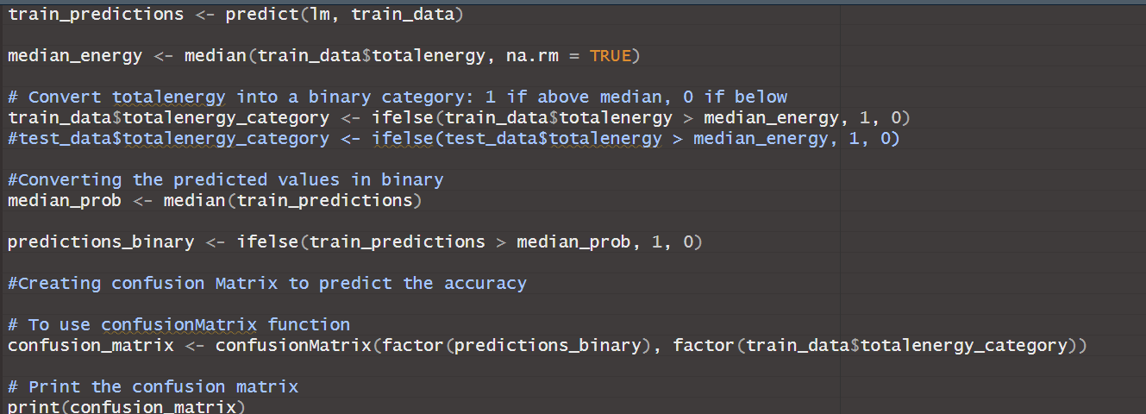

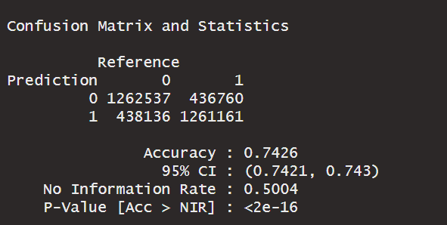

- The model achieved an accuracy of 74.26% on the training data, as indicated by the confusion matrix.
- 1,262,537 correct predictions were made for class '0' (negative cases).
- 1,261,161 correct predictions were made for class '1' (positive cases).
- The model misclassified 438,136 instances of class '1' as class '0'.
- The model also misclassified 436,760 instances of class '0' as class '1'.
- Overall, the model shows a relatively robust performance in classifying both positive and negative cases, despite some misclassifications.

- Testing the accuracy of model on test data:
The accuracy of the model was evaluated on the test data to assess its generalizability and performance on unseen observations.
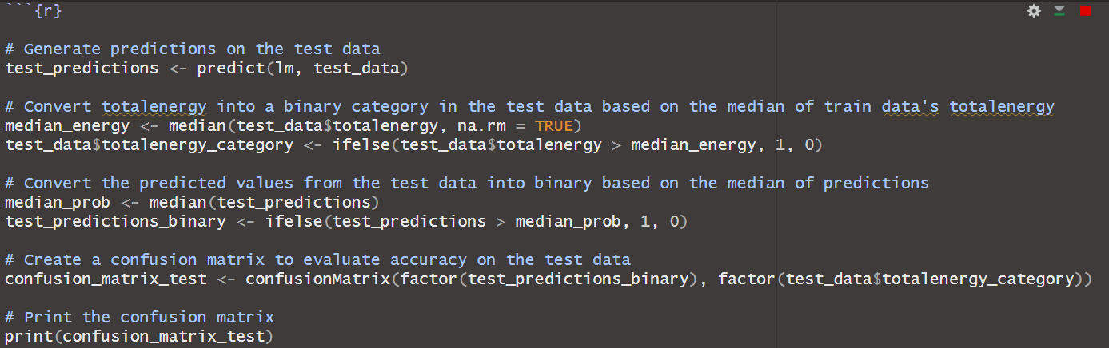

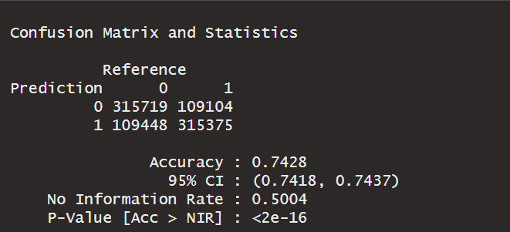
- The model achieved an accuracy of 74.26% on the training data, as indicated by the confusion matrix.
- 1,262,537 correct predictions were made for class '0' (negative cases).
- 1,261,161 correct predictions were made for class '1' (positive cases).
- The model misclassified 438,136 instances of class '1' as class '0'.
- The model also misclassified 436,760 instances of class '0' as class '1'.
- Overall, the model shows a relatively robust performance in classifying both positive and negative cases, despite some misclassifications.
- Testing the accuracy of model through a plot of the residuals:
The accuracy of the model was evaluated by plotting the residuals, using our test data.
- On the above plot, we looked for a normal distribution of residuals focused around 0, which ensures the model’s accuracy is not an issue. We can see that the distribution is not normal, but a major skewness is not apparent implying that the model does not contain accuracy issues.
- We can see that the distribution is not normal, but a major skewness is not apparent implying that the model does not contain accuracy issues.

- Evaluating Peak Future Demand
- Increase in Total Energy Demand for July:

- In the above code and figure, we analysed how much total energy demand would increase due to the rise in temperature for next July, based on the model we previously created and tested.
- As you can see, total energy demand could increase by around 23% because of climate change.
- This projection does not show peak demand at any one time or for any one population, but for our clients for the entire month of July, meaning that this is a general prediction of what to expect next July.

- Analysing Peak Demand for a Single Building for a Single Hour:
- In the above code, we analysed the peak energy demand for any building for a single hour.
- This year’s peak energy demand for a single hour in July from a single building was 23.906 kWh, while the peak future demand was estimated to be 4.66 kWh.
- The reason that our model wasn’t able to capture the same or even a similar peak is due to outliers in the original dataset that the model is unable to predict for. Still, despite this difference in peak demand for a single building for a single hour, we can still get an accurate assessment for how much demand there will be across the board for a given hour (see example below).

- Analysing Peak Demand by City:

- In the first image above, we can see by how much peak energy demand for any single hour will increase for each city in the data set, which is then converted into a percentage increase in the second image.
- In regards to the previous section, forecasting an increase in demand for each city and by how much the increase will be is more important than having a forecast for a higher peak for a building for a single hour because eCS will be able to prepare for each city collectively and not each building individually, which would be very complex.
- The above graphs can provide insight into where energy demand is more likely to increase due to the increase in temperature, allowing eCS to prioritize energy usage reduction in certain cities.
- Below is the code for the above graphs, respectively.

Graph 1:
Graph 2:

- Analysing Peak Demand by Timezone (time of day):
- In the graph above, we can analyse and differentiate the energy average energy demand by the time of day. We can see that energy demand increases as the day goes on until you reach nighttime, which is when demand drops off and begins to decrease.
- This graph can imply that a mitigation of energy usage from afternoon and evening times to the night and midnight can decrease peak energy demand and decrease the risk of blackouts.
- Below is the code for the above graph.

- Recommendations for Energy Efficiency
- Promote Central AC for Efficiency:
  - Encourage the use of Central AC systems over Room AC units, as they showed lower energy consumption and better efficiency in the regression analysis. Central AC serves as the most energy-efficient option for cooling.
  - For areas where Central AC may not be feasible, consider Heat Pumps, which offer a moderate increase in energy consumption compared to Room AC and may provide benefits such as year-round heating and cooling.
- Encourage LED Lighting:
  - Replace compact fluorescent lamps and incandescent bulbs with LED lighting, which is more energy-efficient and can significantly reduce overall energy consumption.
  - As seen in the 1st graph, using our predicted energy demand values we were able to infer that LED’s will demand less energy per hour (kWh) when compared to the other two forms of lighting.
  - As seen in the 2nd graph, we were able to conclude that LED’s are the least common form of lighting when analysing which type of lighting each building used the most. This implies that there is major room for improvement regarding efficient energy usage related to lighting.
  - As seen in the following image, an approach that can be taken to decrease energy demand would be to convert a percentage of CFL and incandescent bulb users into LED users. A simple conversion of 25% of each population could reduce predicted energy demand by 82,475 kWh and as that conversion rate increases energy demand will continue to decrease.

- Optimize Energy Use During Peak Times:
  - Focus energy conservation efforts on high-usage periods, particularly during evenings, by adjusting HVAC systems and lighting through automated controls.
- Improve Building Insulation:
  - Retrofit buildings with improved thermal insulation, such as using wood-frame walls, to reduce energy consumption by enhancing the building’s ability to retain heat or cool air.
- Promote Energy-Saving Behavioral Changes:
  - Educate households, especially larger ones, on energy-saving habits such as adjusting thermostat settings and turning off unused appliances to reduce unnecessary energy use.

7. Shiny Application
- We have created a shiny application, which allows the user to explore the data and see which variables were used within our model in conjunction with accuracy statistics for our model.
- The screenshot below shows the main tab of the shiny application, which includes some interactive features, like filters that enable the user to sort the data as they see fit and then see the average current energy demand for the filtered data and the average predicted energy demand for the filtered data.
- The URL has been given in the adjacent submission box on blackboard.

8. Challenges
While progress has been steady, these are the challenges we have faced:
- Energy usage data extraction for multiple building ID’s:
- A significant challenge was developing the code to extract energy usage data for each building ID from the provided dataset. Each building has its own unique data file, requiring the extraction of information for 5710 different houses. This necessitated careful handling of file paths and building IDs to ensure the correct data was retrieved for each property.

- Performance Optimization for Energy Usage Data Extraction:
- Due to the large volume of data, extracting and loading data for all 5710 houses has resulted in long processing times.

- Merging the three data set together:
- A key challenge is finding a common variable to merge the three datasets (energy usage, static house, and weather data) effectively. Identifying the appropriate variables and ensuring data consistency is essential for successful integration and analysis.

- Splitting the data for analysis:
- Another major challenge is figuring out how to split the data in sets to analyze variables and identify the primary factors contributing to the highest energy consumption. The goal is to cover at least 80% of the buildings in the analysis while ensuring the data is formatted in a way that allows for clean, non-cluttered visualizations. The solution requires careful data segmentation and selection of relevant variables, with a focus on visual clarity in charts.

- Variable Selection for Analysis:
- With over 170 variables across the three datasets (energy, static house, and weather), many of which are categorical, interpreting the relationships between these variables and total energy consumption has been challenging. The large number of variables, coupled with the sheer size of the data, often results in cluttered visualizations. Selecting the most relevant variables for analysis has been crucial to improving interpretability and model accuracy.

9. Project Timeline:
Below is the project timeline, outlining key milestones, status updates, and the final completion date:

Project Update | Date
First Update | 11/17/2024
Second Update | 11/24/2024
Third Update | 12/01/2024
Project Presentation | 12/05/2024
Project Report and Code | 12/08/2024
Project Shiny App | 12/08/2024

10. Team Contributions
Below is the summary of work completed by each member for this update:
- Malhar Mahajan:
- Data Preparation, Cleaning, Exploration, and Merging:
  - Conducted thorough data preparation by merging relevant datasets, aggregating hourly energy usage into a comprehensive "total energy" variable, and cleaning the data by removing irrelevant, null, and redundant variables to ensure quality input for analysis.
- Data Validation:
  - Ensured the accuracy and consistency of the dataset through rigorous validation processes, addressing any anomalies or inconsistencies to maintain the integrity of the analysis.
- Identification of Key Variables:
  - Identified potential variables that significantly impact energy consumption, exploring various categories such as time zones, geographic factors, and appliance usage to inform the subsequent model development.
- Model Development and Refinement:
  - Developed a linear regression model using stepwise regression techniques, splitting the dataset into training and testing subsets to evaluate model performance. Refined the model by removing high p-value variables to enhance statistical significance and interpretability, ensuring a robust predictive framework.
- Analysis and Prediction:
  - Performed predictive analysis on energy consumption, examining the influence of temperature changes and regional factors on energy demand. These insights were used to forecast consumption patterns and optimize energy usage strategies.
- Reporting and Presentation:
  - Compiled a detailed project report encapsulating the methodology, key findings, and insights derived from the analysis. Developed a PowerPoint presentation to communicate the project results effectively to stakeholders.
- Energy Conservation Recommendations:
  - Formulated actionable recommendations to optimize energy usage and promote conservation based on the analysis of building types, time periods, and environmental conditions, helping to drive energy-efficient practices.

- Ethan Radecki:
- Data Preparation and Exploration:
  - Conducted thorough data preparation by identifying efficient code to load relevant datasets. Able to save and share effective code related to easily loading July energy demand data by building id and weather data by county.
- Identification of Key Variables:
  - Identified potential variables that significantly impact energy consumption, exploring various categories such as time zones, geographic factors, and appliance usage to inform the subsequent model development.
- Model Development and Refinement:
  - Developed a linear regression model using training and testing subsets to evaluate model performance. Refined the model by removing high p-value variables to enhance statistical significance and interpretability, ensuring a robust predictive framework. Identified variables that would benefit from an interaction term within the model, regarding temperature and the subsequent increase in temperature.
- Analysis, Visualizations, and Predictions:
  - Performed predictive analysis on energy consumption, examining the influence of temperature changes and regional factors on energy demand. Created visuals to explain effects certain energy consumption mechanisms had using predicted values derived from our model. These insights were used to forecast consumption patterns and optimize energy usage strategies.
- Reporting and Presentation:
  - Assisted in completing a detailed project report encapsulating the methodology, key findings, and insights derived from the analysis. Developed a PowerPoint presentation to communicate the project results effectively to stakeholders.
- Energy Conservation Recommendations:
  - Formulated actionable recommendations to optimize energy usage and promote conservation based on the analysis of building types, time periods, and environmental conditions, helping to drive energy-efficient practices. Led the approach in converting CFL and Incandescent bulb users to LED lighting to reduce energy consumption.
- Shiny Application:
  - Developed an R-driven ‘Shiny’ application, which can be used to further explain findings to clients, while additionally allowing any user to analyse the data themselves and our predictions in an efficient manner.

- Jaswanth Srinivas Chandu Meesala: -

- Performed an analysis to identify variables that could serve as key indicators for studying energy trends.
- Assisted in Identifying potential variables that significantly impact energy consumption, exploring various categories such as time zones, geographic factors, and appliance usage to inform the subsequent model development.
- Tried to merge the weather, meta, energy usage, house data although the outcomes are not favourable.
- Assisted in completing a detailed project report encapsulating the methodology, key findings, and insights derived from the analysis.
- Assisted in Developing a PowerPoint presentation to communicate the project results effectively to stakeholders.

- Shuai Liu:
- Assisted in powerPoint presentation ，assigned to create and format the PowerPoint presentation for the group.
- Responsible for drafting the outline of the project report. This includes organizing the structure, determining the key sections, and ensuring logical flow for the content.
- Tasked with merge the data, and made an effort to merge weather,meta,energy usage,house data , though the final outcome was not successful.And the rest of the team completed the task.

